
VISVESVARAYA TECHNOLOGICAL UNIVERSITY

BELAGAVI – 590018, Karnataka INTERNSHIP REPORT

ON “Template for VTU SGPA/CGPA Calculator”
Submitted in partial fulfilment for the award of degree(18CSI85)

BACHELOR OF ENGINEERING IN

COMPUTER SCIENCE
Submitted by:

MEGHANA A

4VM19CS028


Conducted at
Varcons Technologies Pvt.Ltd



VIDYA VIKAS INSTITUTE OF ENGINEERING AND TECHNOLOGY
Department of Computer Science
Accredited by NBA, New Delhi

#127-128,Mysore-Bannur Road,Alanahally,Mysore,Karnataka-570028

VIDYA VIKAS INSTITUTE OF ENGINEERING AND TECHNOLOGY
Department of Computer Science
Accredited by NBA, New Delhi

#127-128,Mysore-Bannur Road,Alanahally,Mysore,Karnataka-570028



CERTIFICATE

This is to certify that the Internship titled “Template for VTU SGPA/CGPA Calculator” carried out by Meghana A(4VM19CS028), a bonafide student of Vidya Vikas Institute of Engineering and Technology, in partial fulfillment for the award of Bachelor of Engineering, in Computer Science under Visvesvaraya Technological University, Belagavi, during the year 2022-2023. It is certified that all corrections/suggestions indicated have been incorporated in the report.
The project report has been approved as it satisfies the academic requirements in respect of Internship prescribed for the course Internship / Professional Practice (18CSI85)

Signature of Guide Signature of HOD Signature of Principal

External Viva:

Name of the Examiner Signature with Date

1)

2)

D E C L A R A T I O N

I, Meghana A, final year student of Computer Science, Vidya Vikas Institute of Engineering and Technology - 570 028, declare that the Internship has been successfully completed, in Varcons technologies Pvt.Ltd. This report is submitted in partial fulfillment of the requirements for award of Bachelor Degree in Branch name, during the academic year 2022-2023.

Date :23/09/2022 :
Place : Mysore
USN : 4VM19CS028
NAME : Meghana A
CERTIFICATE OF INTERNSHIP COMPLETION

Date: 23rd August, 2022

Name: Meghana A
USN: 4VM19CS028

Dear Student,
We would like to congratulate you on being selected for the Full Stack Web Development Internship position with Varcons Technologies Pvt Ltd, effective Start Date 23rd August, 2022, All of us are excited about this opportunity provided to you!

This internship is viewed as being an educational opportunity for you, rather than a part-time job. As such, your internship will include training/orientation and focus primarily on learning and developing new skills and gaining a deeper understanding of concepts of Full Stack Web Development through hands-on application of the knowledge you learn while you train with the senior developers. You will be bound to follow the rules and regulations of the company during your internship duration.

Again, congratulations and we look forward to working with you!.

Sincerely,

Spoorthi H C
Director
Varcons Technologies Pvt Ltd
213, 2st Floor,
18 M G Road, Ulsoor,
Bangalore-560001

A C K N O W L E D G E M E N T

This Internship is a result of accumulated guidance, direction and support of several important persons. We take this opportunity to express our gratitude to all who have helped us to complete the Internship.

We express our sincere thanks to our Principal, for providing us adequate facilities to undertake this Internship.

We would like to thank our Head of Dept – branch code, for providing us an opportunity to carry out Internship and for his valuable guidance and support.

We would like to thank our (Lab assistant name) Software Services for guiding us during the period of internship.

We express our deep and profound gratitude to our guide, Guide name, Assistant/Associate Prof, for her keen interest and encouragement at every step in completing the Internship.

We would like to thank all the faculty members of our department for the support extended during the course of Internship.

We would like to thank the non-teaching members of our dept, forhelping us during the Internship.

Last but not the least, we would like to thank our parents and friends without whose constant help, the completion of Internship would have not been possible.

Meghana A
4VM19CS028

ABSTRACT

This SGPA calculator was built to help VTU students calculate their SGPA,iIt may be flexible enough to work with your university as well.
And it is just add the Mark's to the respctive subject and click the submit button to know the sgpa.

Our project is based on calculate SGPA/CGPA. The most of the students face a problem to calculate their marks by SGPA & CGPA. In our project we will give the following details.

- Course and Semester information(credits & points)
- How to calculate SGPA?
- How to calculate CGPA?

The given project “Template for VTU SGPA/CGPA Calculator” is very helpful to for calculation marks into point with grade. This is very useful for university students like ours.

Table of Contents

Contents Page No.

Abstract 6

Table of Contents 7

Company Profile 8-9

About the Company 10-11

Introduction 12-13

Requirement Analysis 14-15

Implementation 16-19

Snapshots 20-22

Conclusion 23-24

References 25-26

CHAPTER 1 COMPANY PROFILE

COMPANY PROFILE

A Brief History of Varcons Technologies Pvt.Ltd
Varcons Technologies is a leading provider of cutting-edge technologies and services, offering scalable solutions for businesses of all sizes. Founded by a group of friends who started by scribbling their ideas on a piece of paper, today we offer smart, innovative services to dozens of clients. We develop SaaS products, provide Corporate Seminars, Industrial trainings and much more.
Varcons Technologies, strive to be the front runner in creativity and innovation in software development through their well-researched expertise and establish it as an out of the box software development company in Bangalore, India. As a software development company, they translate this software development expertise into value for their customers through their professional solutions.
They understand that the best desired output can be achieved only by understanding the clients demand better. Varcons Technologies work with their clients and help them to defiine their exact solution requirement. Sometimes even they wonder that they have completely redefined their solution or new application requirement during the brainstorming session, and here they position themselves as an IT solutions consulting group comprising of high caliber consultants.

They believe that Technology when used properly can help any business to scale and achieve new heights of success. It helps Improve its efficiency, profitability, reliability; to put it in one sentence ” Technology helps you to Delight your Customers” and that is what we want to achieve.

CHAPTER 2 ABOUT THE COMPANY

- ABOUT THE COMPANY


Varcons Technologies is a Technology Organization providing solutions for all web design and development, MYSQL, PYTHON Programming, HTML, CSS, ASP.NET and LINQ.The organization where they have a right mix of professionals as a stakeholders to help us serve our clients with best of our capability and with at par industry standards. They have young, enthusiastic, passionate and creative Professionals to develop technological innovations in the field of Mobile technologies, Web applications as well as Business and Enterprise solution. Motto of our organization is to “Collaborate with our clients to provide them with best Technological solution hence creating Good Present and Better Future for our client which will bring a cascading a positive effect in their business shape as well”. Providing a Complete suite of technical solutions is not just our tag line, it is Our Vision for Our Clients and for Us, We strive hard to achieve it.

Services provided by Varcons Technologies.
- Core Java and Advanced Java

- Web services and development

- Python

- Conference / Event Management Service

- Academic Project Guidance

- On The Job Training

- Software Training

CHAPTER 3 INTRODUCTION

- INTRODUCTION

Introduction

The full form of CGPA is Cummulative Grade Point Average. CGPA is an assessment tool used to evaluate student academic performance.

SGPA stands for Semester Grade Point Average. It calculates the total scores and credits at the end of the term or session. It is average of all grade points secured in all examination during one semester.

To calculate your grade point average, first multiply the number of credits each class is worth by the point value for the letter grade that you earned in that class. Next total the grade points of all your classes for that semester and divide it by the number of credit hours that you attempted.

Project Scope

The scope of the project is to calculate SGPA/CGPA easily and it is efficient for student. Whom want to calculate their SGPA/CGPA just input their number then this program automatically calculates their SGPA/CGPA and show them

CHAPTER 4 REQUIREMENT ANALYSIS

4. REQUIREMENT ANALYSIS

Hardware Requirement Specification
  - Html
  - 128MB Ram

  - Memory: 15.6 GB

  - Hard Disk: 40 GB

Software Requirement Specification

  - Visual Studio
  - Xampp
  - Operating System(Window 10)

CHAPTER 5

IMPLEMENTATION

5. IMPLEMENTATION

<!DOCTYPE html>
<html>
<head>
<meta name="viewport" content="width=device-width, initialscale=1"content="width=device-height, initial-scale=1" />
<title>2021 SGPA 1st sem</title>
<script>
function calculate()
{
var a=parseInt(document.getElementById("mat").value);
var b=parseInt(document.getElementById("che").value);
var c=parseInt(document.getElementById("psp").value);
var d=parseInt(document.getElementById("eln").value);
var e=parseInt(document.getElementById("eme").value);
var f=parseInt(document.getElementById("chel").value);
var g=parseInt(document.getElementById("cpl").value);
var h=parseInt(document.getElementById("egh").value);
var i=parseInt(document.getElementById("sfh").value);
var aa=3*marks(a);
var ab=3*marks(b);
var ac=3*marks(c);
var ad=3*marks(d);
var ae=3*marks(e);
var af=1*marks(f);
var ag=1*marks(g);
var ah=2*marks(h);
var ai=1*marks(i);
var z=((aa+ab+ac+ad+ae+af+ag+ah+ai)/200)*10;

document.getElementById("res").value=parseFloat(z);
}

function marks(y)
{
if(y>=90)
return 10;
else if (y<=89&&y>=80)
return 9;
else if (y<=79&&y>=70)
return 8;
else if (y<=69&&y>=60)
return 7;
else if (y<=59&&y>=50)
return 6;
else if (y<=49&&y>=45)
return 5;
else if (y<=44&&y>=40)
return 4;
else
return 0;

}
</script>
<style>

#calc {
background-color: aqua;
padding: 0.5% 2% 0.5% 2%;
font-size: 100%;
}

label{

color: aliceblue;
margin-top: 5%;
font-weight: bold;
}
input{
background-color: rgb(221, 239, 137);
margin: 1% 0 2% 0 ;
font-weight: bold;
text-align: center;
font-size: 100%;
}
*{
background-color: rgb(5, 13, 76);
}
#res{
font-size: 200%;
width: 150px;
background-color: rgb(217, 237, 198);
color: red;
}
#h{
color: red;
font-size: x-large;
margin-bottom: 7%;
font-family: 'Franklin Gothic Medium', 'Arial Narrow', Arial, sans-serif;

}

</style>
</head>
<center>
<body id="bd">
<b id="h">2021 SGPA CALCULATOR</b>
<br>
<br>

<label>21MAT11 : </label>
<br>
<input type="text" id="mat">
</br>
<label>21CHE12/21PHY12 : </label>
</br>
<input type="text" id="che">
</br>
<label>21PSP13/ 21ELE13 : </label>
</br>
<input type="text" id="psp">
</br>
<label>21ELN14/21CIV14 : </label>
<br>
<input type="text" id="eln">
</br>
<label>21EME15/21EVNL15 : </label>
<br>
<input type="text" id="eme">
</br>
<label>21CHEL16/21PHYL16: </label>
<br>
<input type="text" id="chel">
</br>
<label>21CPL17/21ELEL17 : </label>
<br>
<input type="text" id="cpl">
</br>
<label>21EGH18 : </label>
<br>
<input type="text" id="egh">
</br>
<label>21SFH19/21IDT19 : </label>
<br>
<input type="text" id="sfh">
</br>
<input type="button" value="calculate" id="calc" onclick="calculate()"></input>
<p style="color:red; font-size:large">Your CGPA/SGPA is</p>
<input type="text" id="res" disabled>
</center>
</body>

</html>

CHAPTER 6
SNAPSHOTS

6. SNAPSHOTS

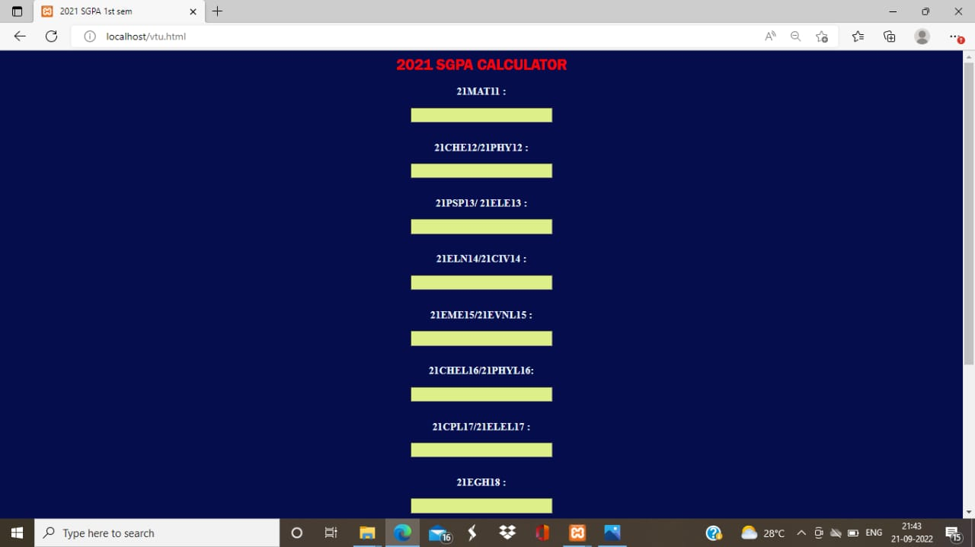

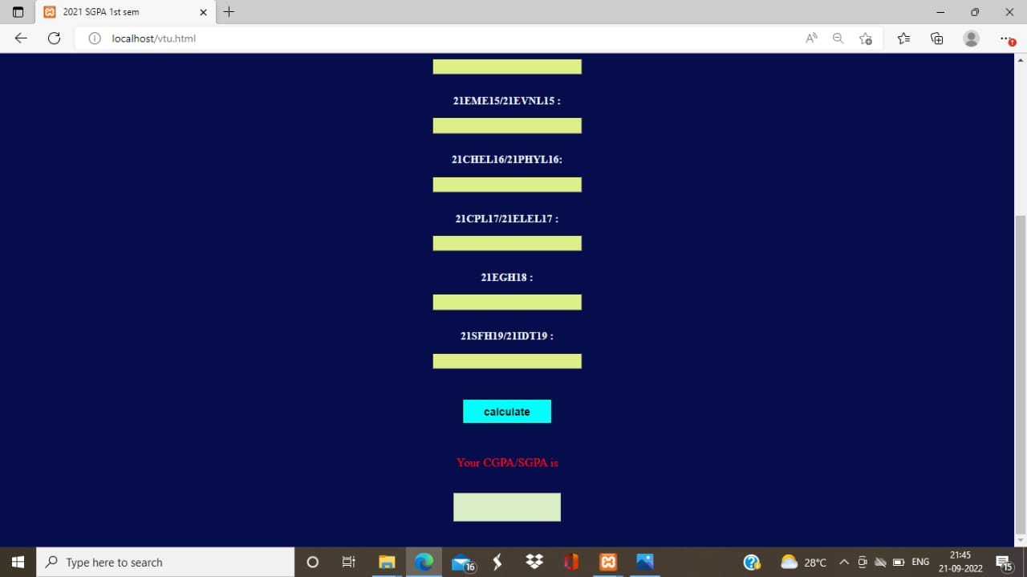

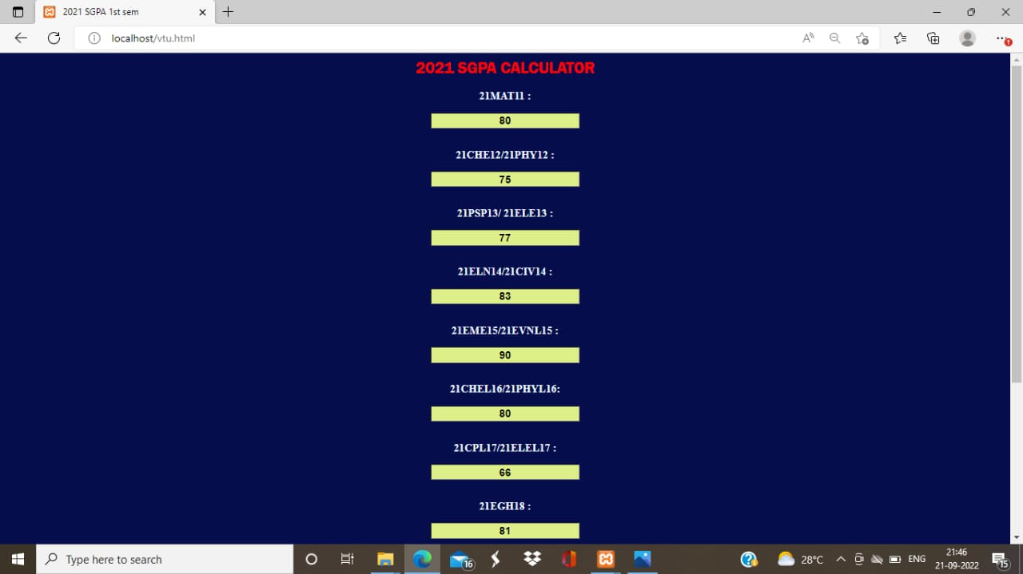

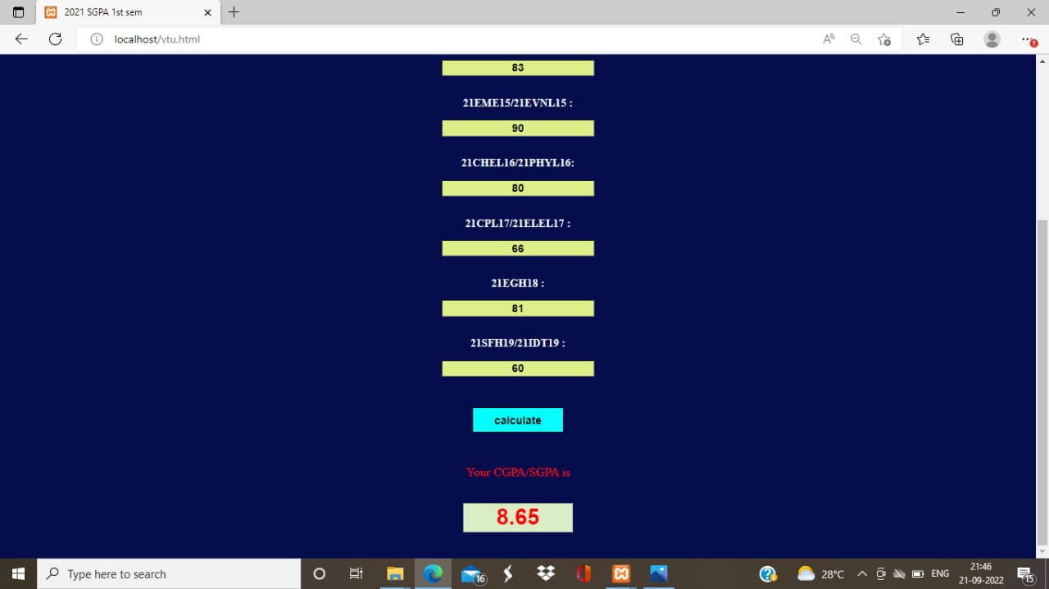

CHAPTER 7

CONCLUSION
7.CONCLUSION

The project titled as Template for VTU SGPA/CGPA Calculator was deeply studied and analyzed to design the code and implement.It was done under the guidance of the experienced project guide.All the current requirements and possibilities have been taken care during the project time.

SGPA/CGPA calculating system is used for daily operations in any university to Calculate their student SGPA/CGPA and student can also easily calculate their SGPA/CGPA.

CHAPTER 8 REFERENCES

8. REFERENCE

1. https://www.scribd.com/document/468177935/CGPA-calculator-project-report

2.https://github.com/Pavankulal2002/sgpacalculator2021.git

3. https://github.com/Pavankulal2002/sgpacalculator2021

